## Crypto-Solutions

# Magic Triangle

CORRECT ANSWER: 5 possible correct solutions. Sum of the row: 17, 19, 21, 20, 23.

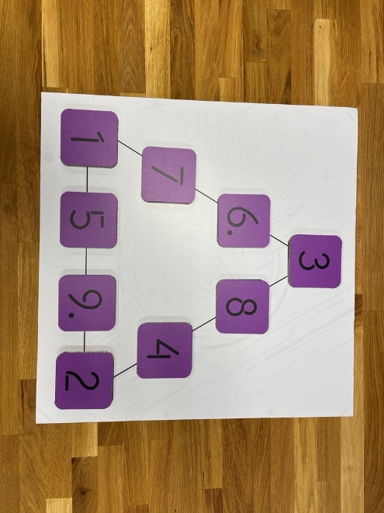

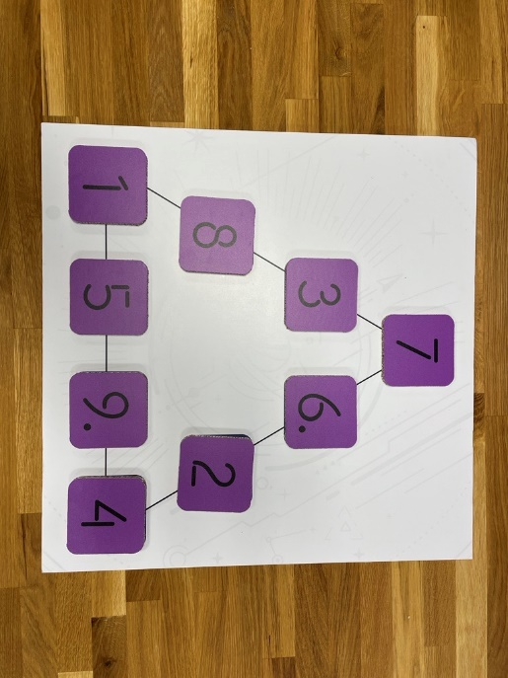 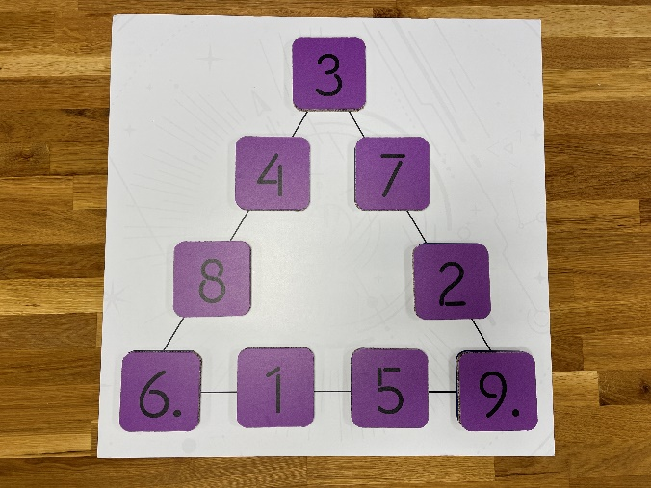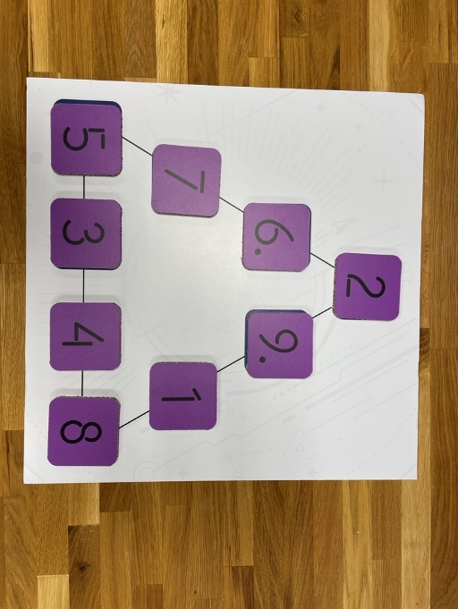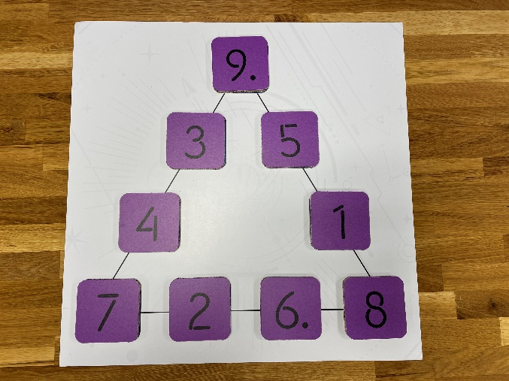.

# TAKE OFF bank

CORRECT ANSWER: 1058+977=2035

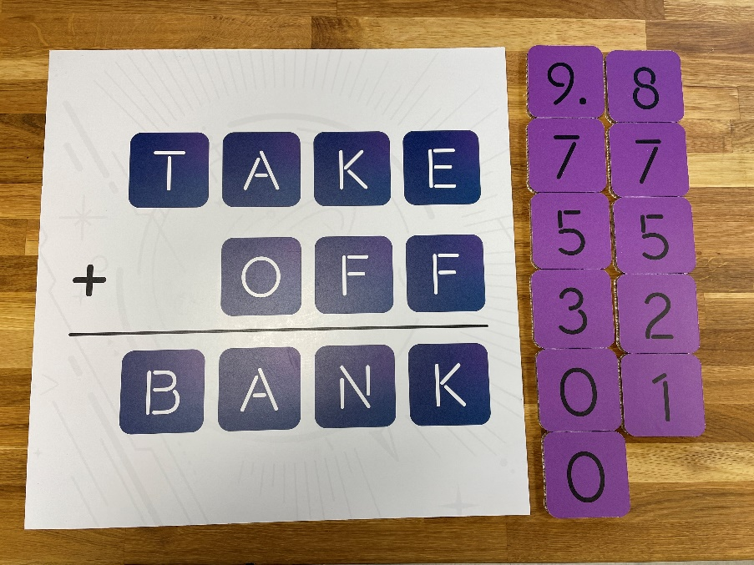

# Kakuro

CORRECT ANSWER:

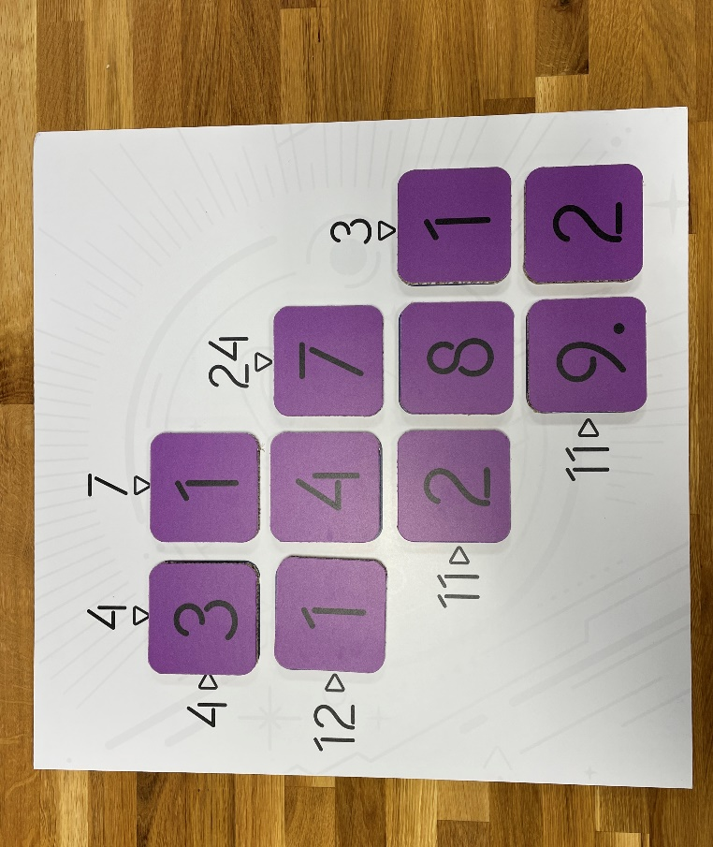

# Letter Puzzle (T)

<https://en.wikipedia.org/wiki/T_puzzle>

CORRECT ANSWER:

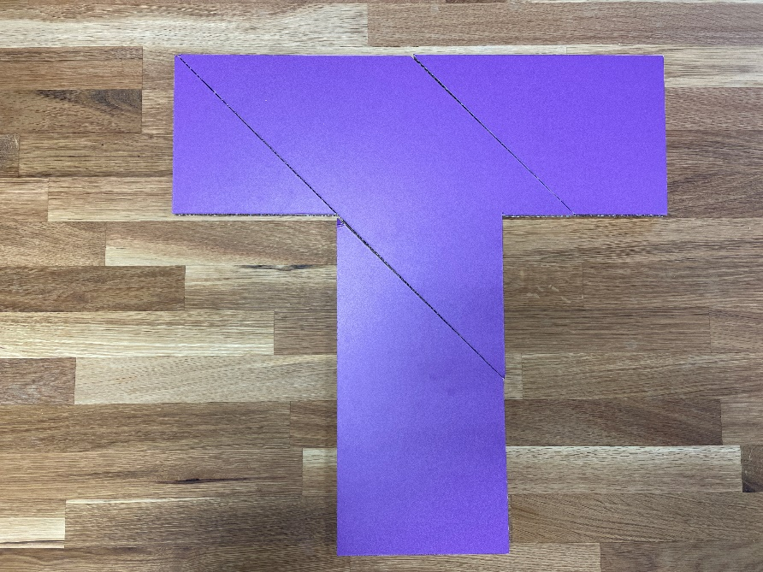

# Sudoku

CORRECT ANSWER:

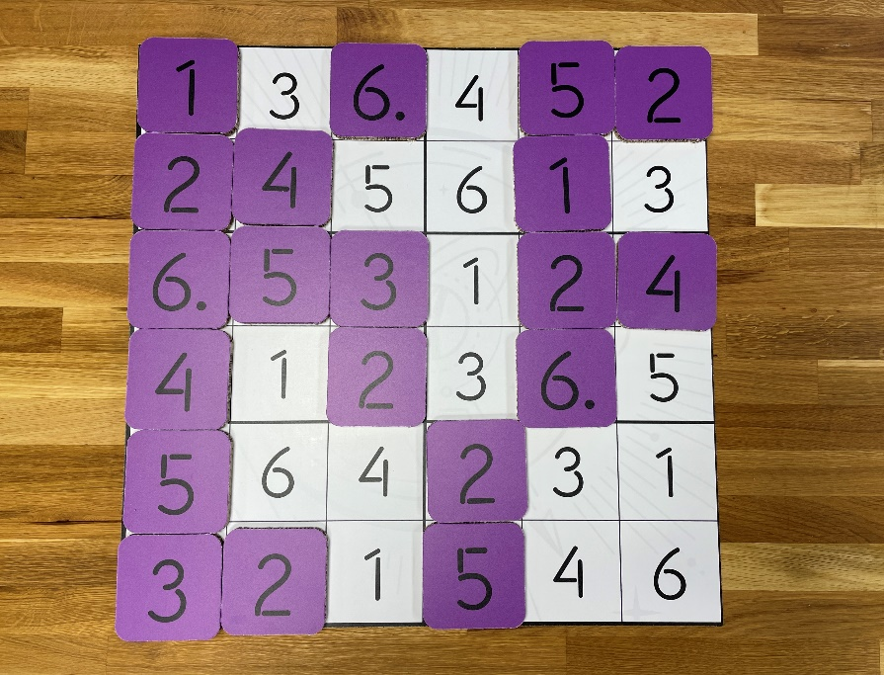

# Magic Square

CORRECT ANSWER:

